**SMART WASTE MANAGEMENT USING IOT IN METROPOLITAN CITIES**

**Team Members: Arockia Kishore K**

**Ashik J**

**Balajee B**

**Gokul Raj L**

**College: Jeppiaar Engineering College**

**Abstract**

The municipal solid waste generation levels are increasing significantly with the ever increasing population, urbanization, migration issues and change in lifestyle. Waste management becomes a challenge faced not only by the developing nations, but also the developed and advanced countries. The efficient management of waste has a significant impact on the quality of life of citizens. The reason is that waste disposal has a clear connection with negative impacts in the environment and thus on citizens’ health. Also the quantity of waste near to streets caused to bad smell and bad hygienic condition. It also provides negative impact on tourism. The smart waste management system helps to remove the waste in appropriate time without overflowing and also provides better waste management.

**Keywords**

Cloud IBM, Internet Of Things

**INTRODUCTION**

The solid waste is increasing in urban and rural areas as the population is increasing and waste management has become a global concern. In order to manage this overflowing garbage we need to take right decision. Mainly there are three types of sources where garbage is generated, residential, commercial and industrial. The garbage produced in the residential area can be collected directly from home or by making an arrangement for mass collection in that area and can be lifted using vehicles. In case of restaurants, malls and other commercial establishment garbage can be collected directly from the unit using vehicles. Industrial garbage which includes waste produced in construction sites, various industries can also be disposed using different ways. For effective handling of these wastes like collection and disposal, Internet of Things (IOT) concept is being used, which mainly deals with sensing, actuating, data gathering, storing and processing by connecting physical and virtual devices to the Internet.

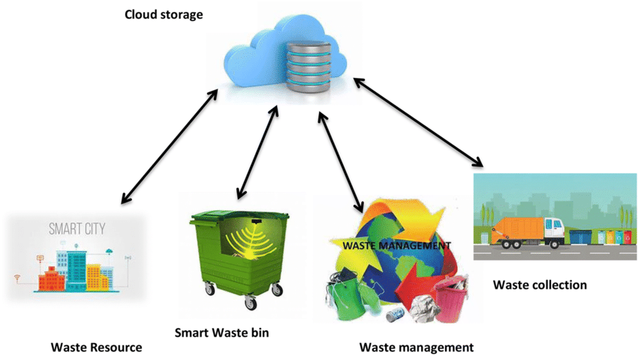

**LITERATURE SURVEY**

This is an IOT based dustbin implemented and effectuated much before. Some authors presented systems where the sensors in the bin checked if the bin are filled up to the brim or not. If it was filled an automated message was sent to the server end of the system, through the Arduino SIM module, which used the application of the Arduino board. Once the server received the message it forwarded the message to the worker in charge, if the worker was available, he would notify his/her presence by accepting the work and would reach the required destination. If the worker was not available, the work would be transferred to another worker.

Some authors also implemented real time waste management system by using smart dustbins to check the filled level of dustbins whether they were filled. In this system the information of all smart dustbins can be accessed from anywhere and anytime by the concern person and he/she can take a decision accordingly. By implementing this proposed system, the cost reduction, resource optimization, effective usage of smart dustbins was carried out. This system indirectly reduced traffic in the city. In major cities the garbage collection vehicle visited the area’s everyday twice or thrice depending on the population of the particular area. The System informed the status of each and every dust bin in real time so that the concerned authority can send the garbage collection vehicle only when the dustbin is full. Some proposed smart garbage management system using IR sensor, microcontroller and Wi-Fi module.

This system assured the cleaning of dustbins soon when the garbage level reached its maximum. If the dustbin was not cleaned in specific time, then the records were sent to the higher authority who took appropriate action against the concerned contractor. This system also helped to monitor the fake reports and hence helped to reduce the corruption in the overall management system. It ultimately helped to keep cleanliness in the society Progressively the Dustbin with Wi-Fi Router attachedin it was also introduced. The Dustbin had a Passive Infrared Sensor. The Wi-Fi router was programmed to display the temporary connecting code. When the user throwed trash in the dustbin, the PIR sensor detected the trash and sent signals to the microcontroller. The microcontroller detected the signals and forwarded it to the router device. The router verified the signals and generated random codes and then forwarded it again to the microcontroller.

The microcontroller scanned the signals and forwarded it to the LCD Display. The LCD Display displayed it. The user entered the random code generated by the router on the PHP interface which was hosted on the server. The server then responded to the request and displayed the Master Wi-Fi password to the user. The user then used the Master Wi-Fi password to connect to the internet. The user got the internet access for 10 minutes and automatically got disconnected.

The system is composed of following components:

1.Dustbin:

A normal dustbin made of plastic or metal which can hold up all the components installed in it the mechanical shredder installed on the top side and the load sensing plate at the mediocre level all the IOT components will be installed at the bottom side. Thus, it should be of average size (height_600-700 mm diameter

2.Sensor:

The sensing unit will mainly consist of 2 sensors i.e. the load sensor and the IR sensor the load sensor used for measuring the weight of trash being dumped into the dustbin and this is attached to the bottom side of load sensing plate, the IR sensor will detect the downward motion of trash once the load sensing plate s pulled out and the trash falls down in the bin

3. Load cell:

During a measurement, weight acts on the load cell's metal spring element and causes elastic deformation. This strain (positive or negative) is converted into an electrical signal by a strain gauge (SG) that is installed on the spring element. Product Name: Load Cell Load: 10Kg /22lb Rated Output: 1+/-0.15mV/V Recommend Excitation Voltage: DC 5V; Max Excitation Voltage: DC 10V Fig.3: Load Sensor

4. IR sensor:

An infrared sensor is an electronic instrument that is used to sense certain characteristics of its surroundings. It does this by either emitting or detecting infrared radiation. Infrared sensors are also capable of measuring the heat being emitted by an object and detecting motion. Operating Voltage Range 3.6~5 VDC Average Current Consumption (mA) 0.06 Detection Angle 35 Â° Distance Measuring Range 2 ~ 30cm.

5. Wi-Fi module:

It consists of the router which will provide the internet facilities to the user for dumping the trash into the bin

6. Microcontroller:

Arduino will be the processing unit for the embedded system at the bins. This will be used for controlling sensors and send information. The other components include:

HX711 amplifier:

Differential input voltage: ±40mV (Full-scale differential input voltage is ± 40mV) Operating Voltage: 2.7V to 5VDC Operating current:

Advantages:

The proposed plan has many advantages, it is also cogent enough to be implemented in every street of a developing nation. the advantages lie in its easy and valuable functioning. This will not only improve the streets we live in, but also provide a pavement for better working system.

• Efficient and effective Functioning.

• Cleaner Environs

• Better health issues.

• Pollution free and stinking free environs

• Smart cities

• Technology development

• Tourist attraction.

Once implemented, this method would be easy to work on. The garbage will be dumped into the bins thereby reducing the health-threats imposed by the trash present all-around.

Future Works:

The moisture sensor can be implemented hand in hand with the other sensors and the compartments for segregating the dry and wet waste can be created which will solve the issues related to waste segregation.

Conclusion:

Improper disposal and improper maintainance of domestic waste create issues in public health and environment pollution thus this paper attempts to provide practical solution towards managing the waste collaborating it with the use of IOT i.e. providing free internet facilities for a specific time once the trash is dumped into the bin. the proposed system will definitely help to overcome all the serious issues related to waste and keep the environment clean

References:

[1] P. Suresh, Vijay. Daniel, R.H. Aswathy, Dr. V. Parthasarathy, “A State-of-the-Art review on Internet of Things” International Conference on Science Engineering and Management Research (ICSEMR), IEEE, DOI: 10.1109/ICSEMR.2014.7043637 19 February 2015.

[2] Parkash, Prabu V “IoT Based Waste Management for Smart City” International Journal of Innovative Research in Computer and Communication Engineering, Vol. 4, Issue 2, DOI: 10.15680/IJIRCCE.2016. 0402029, February 2016.

[3] Evaluation on the Performance of Urban Domestic Sewage Treatment Plants in China - 2011 Dongmei Han; Guojun Song

[4] Teemu Nuortioa, Jari Kyto¨jokib, Harri Niskaa, Olli Bra¨ysyb “Improved route planning and scheduling of waste collection and transport”, Expert Systems with Applications 30 (2006) 223– 232, Elsevier

[5] M. Arebey, M. Hannan, H. Basri, and H. Abdullah, "Solid waste monitoring and management using RFID, GIS and GSM", The IEEE Student Conference on Research and Development (SCOReD), 16-18 November 2009, UPM Serdang, Malaysia, 2009

[6] M. Hannan, M. Arebey, R. A. Begum, and H. Basri, "Radio Frequency Identification (RFID) and communication technologies for solid waste bin and truck monitoring system", Waste Management, Vol. 31, pp. 2406-2413, 2011.

[7] S. Longhi, D. Marzioni, E. Alidori, G. Di Buo, M. Prist, M. Grisostomi, et al., "Solid Waste Management Architecture Using Wireless Sensor Network Technology", The 5th International Conference on New Technologies, Mobility and Security (NTMS), 7-10 May 2012, Istanbul, pp. 1-5, 2012. 147

[8] Waikhom Reshmi, RamKumar Sundaram, M. Rajeev Kumar, “Sensor Unit for Waste Management: A Better Method,”, International conference on Science, Engineering and Management Research, ©2014 IEEE